Goaltender dryland basic strength workout 3 x 10
- 15 minute warm-up on stationary bike + stretching
- 3 X 10 of all the moves in the photos
- 10 minute cooldown on stationary bike + stretching

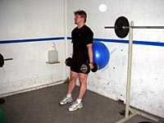 | 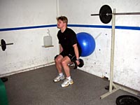
Wall squat. Squat against the ball. Keep you back straight and use appropriate weights.
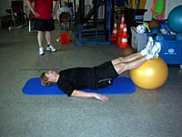 | 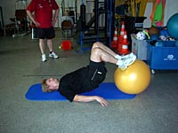
Hip extension knee flexion. Start from your back and first straighten your body and get your back off from the floor. Next bend your knees and last bring the ball back towards you as close as you can get it. Then bring it back and repeat the move.
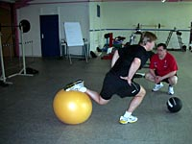 | 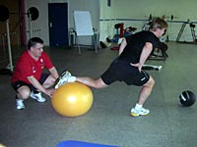
1-Leg squat. Keep your back leg on top of the ball as far as possible while squatting. Coach can help the proper movement by keeping the ball away from getting too close to the goalie. As your goalie advances you can add a small balance board under the front foot too.
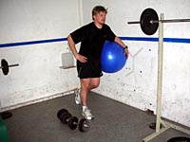 | 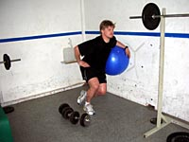
Angled 1-leg wall squat. Keep your inner foot off from the ground while squatting with outer foot and body angled as in the photos.
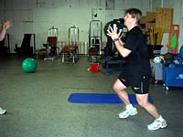 | 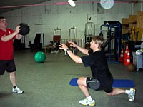
Medicine ball lunge. Pass the medicine ball to the coach or your goalie partner while performing a forward lunge step. Ball will be passed back to you as you push back up. You can do this either with one leg at the time or alternate the leg that comes forward.
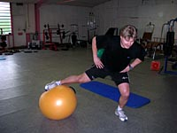 | 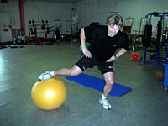
Leg blaster. bring the ball as far as possible from your body and then back to as close as possible while maintaining as hard pressure as you can on the ball by pushing it down with your leg. This is one of the best moves for goalies.
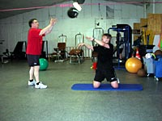 | 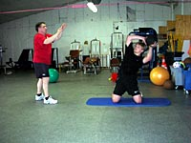
Side pass. In this move you will focus on your midsection by bending with the medicine ball as far to the side as possible. As you came back you toss the ball to the coach or your goalie partner who will give it back to you immediately as you go for another bend.
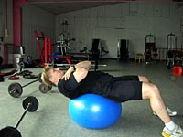 | 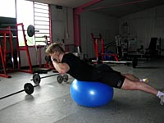
Stomach & back. Finish your round always with set of stomach and back crunches.

Credit: Finnish goalie pro Jukka Ropponen

